MODEL A GAPS

When the word “gap” comes to mind you probably think of the spark plug gap or distributor point gap. These are very important settings to provide for an efficient running engine and if not set correctly you or your engine are not going to be happy.

Well, there is another gap that doesn’t get much publicity and that is gap between the rotor and the distributor body. Just as you count on the spark to “jump” between the electrodes in your spark plugs or the contact points on your distributor upper plate, it must also “jump” between the rotor tip and the contacts in the distributor body housing.

When we install a new set of plugs or points we automatically adjust them, but when we replace a rotor or distributor body we “take for granted” that the manufacturer in Taiwan has good quality control and knows what the specifications are. WRONG!

Just as you would get poor performance if you adjusted each plug different or the lobes in your distributor cam being worn, so would you get poor performance if the “air gap” in the distributor is adjusted different.

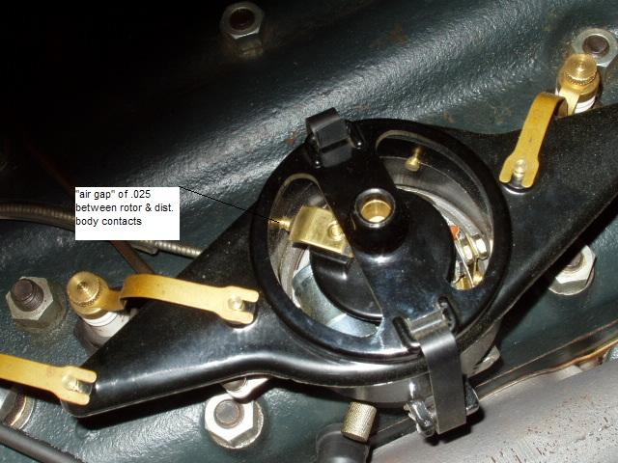

You MUST adjust this gap if you expect good performance. That requires bending the rotor tip and/or filing the contact points so they are all as close to .025 as you can get them. The result will be a smooth running engine when you “wind out” second gear and as you continue down the road at 45-50 MPH.

